8MP IR Fixed-Focal Dome Pro AI Network Camera
- 8 MP 1/2.7" CMOS Sensor
- Support H.264+, H.265+
- The Max. IR LED distance is 40 m
- Support Perimeter Protection, Face Detection, SMD
- Support Built-in Mic & Speaker
- Supports max. 256 G Micro SD card
- 2.8mm fixed lens (3.6mm/6mm optional)
- 12 VDC/PoE power supply
- IP67, IK10 protection
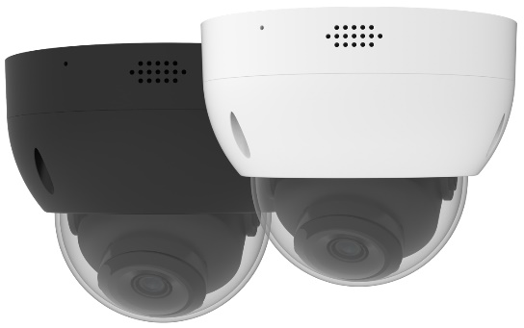

Camera
Image Sensor | 1/2.7” CMOS
Max. Resolution | 8MP,3840 (H) × 2160 (V)
Scanning System | Progressive
Electronic Shutter Speed | Auto/Manual 1/3 s–1/100,000 s
Min. Illumination | 0.007Lux(Color); 0.0007Lux (B/W); 0Lux (Illuminator on)
S/N Ratio | > 56 dB
Illumination Distance | IR Distance 40 m
Illuminator Control | Auto; Manual
Lens
Lens Type | Fixed-Focal
Focal Length | 2.8mm/3.6mm/6.0mm
Max. Aperture | F1.6
Field of View | 2.8 mm: Horizontal:107°; vertical: 56°; diagonal: 127°  3.6 mm: Horizontal:84°; vertical: 47°; diagonal: 97°  6 mm: Horizontal: 55°; Vertical: 29°; Diagonal: 63°
Iris Type | Auto
Intelligence
Smart Motion Detection | Yes
Perimeter Protection | Intrusion,Tripwire(Support the classification of Vehicle, Human and Non-Motor)
Face Detection | Yes
People Counting | Yes
Heat Map | Yes
Video Metadata | NA
AI Search | Work together with NVR
Video
Compression | H.264H; H.264M; H.264B; H.265
Smart Compression | H.264H+; H.264M+; H.264B+; H.265+
Video Frame Rate | Main Stream: 8MP (1 fps–20 fps)
Video Frame Rate | Sub Stream: D1 (1 fps–25/30 fps)
Video Frame Rate | Third Stream: 720P (1 fps–25/30 fps)
Stream Capability | 3 Streams
Bit Rate Control | CBR/VBR
Video Bit Rate | H.264: 3 Kbps–20480 Kbps
Video Bit Rate | H.265: 3 Kbps–20480 Kbps
Day/Night | Color/B/W
BLC | Yes
HLC | Yes
WDR | 120 dB
White Balance | Yes
Gain Control | Auto/Manual
Noise Reduction | 3D NR
Motion Detection | OFF/ON (4 Areas, rectangular)
Image Rotation | 180°
Mirror | Yes
Privacy Masking | 4 Areas
Audio
Built-in Mic | Yes
Built-in Speaker | Yes
Two-way talk | Yes
Audio Compression | G.711a; G.711Mu; G.726; G.726ASF
Alarm
Arming/Disarming | NA
Sound Alarm | Yes
Light Alarm | NA
Alarm Event | Disconnection; IP Conflict; No SD Card; Capacity Warning; SD Card Error
Network
Network | RJ-45 (10/100 Base-T)
SDK and API | Yes
Network Protocol | TCP/IP;UDP;HTTP;IGMP;ICMP;DHCP;RTP/RTSP;DNS;DDNS;FTP;NTP;PPPOE;UPNP;SMTP
Interoperability | ONVIF; CGI; P2P
User/Host | 20 (Total bandwidth: 80 M)
Storage | FTP; Micro SD card (support max. 256 G/FAT32)
Browser | IE: IE8 and later; Chrome; Firefox
Management Software | PC Software(SVMS), APP
Mobile Client | IOS; Android
Port
Audio Input | 1 channel (optional)
Audio Output | 1 channel (optional)
Alarm Input | 1 channel (optional)
Alarm Output | 1 channel (optional)
Power
Power Supply | 12V DC (±30%)/PoE (802.3af)
Power Consumption | Basic: 2.5 W; Max: 5.2W
Environment
Operating Conditions | –30°C to +60°C (–22°F to +140°F)/Less than 95% RH
Storage Conditions | –40°C to +60°C (–40°F to +140°F)
Protection Grade | IP67,IK10
Structure
Casing | Metal
Dimensions | 102 mm × Φ122 mm
Net Weight | 490g

Camera Structure and Dimensions

