MT-8500 series OTDR

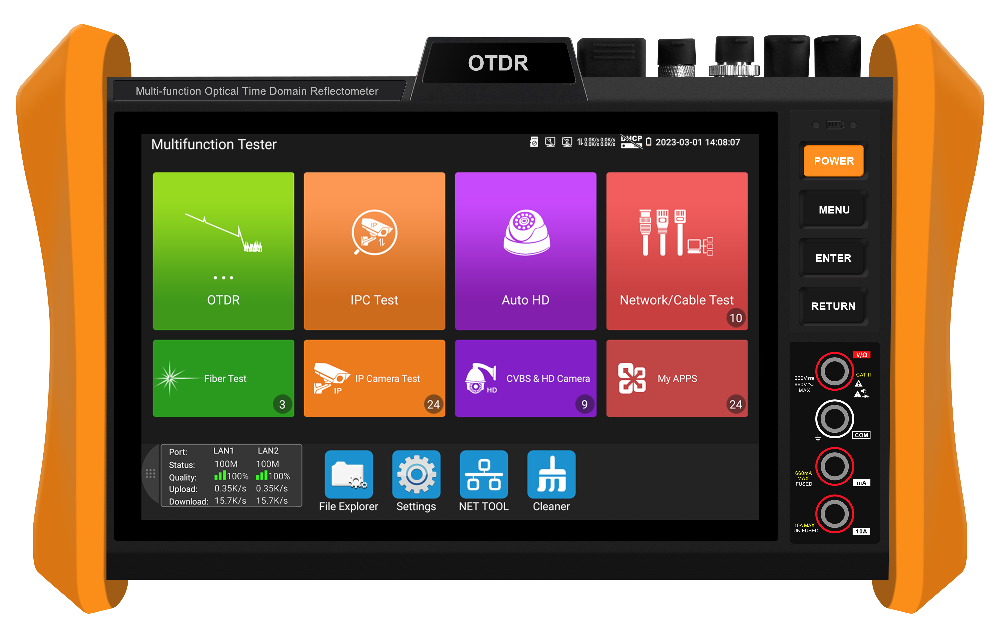

New Generation

8 inch larger touch screen display with 1920 x1200 resolution
Multifunction OTDR combined with 4K IP CCTV tester, cable tester, OPM, VFL and VLS


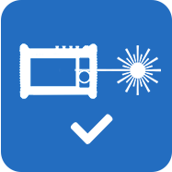
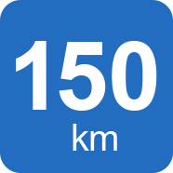
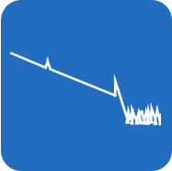



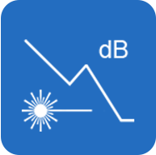
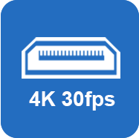


HDMI Optional

Stable laser source
Optical signal

OPM
OTDR testing
WIFI
VFL
Max 150KM
Optical loss test

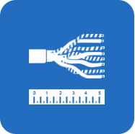

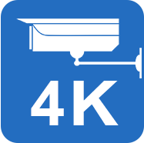




DMM
RJ45 TDR
Cable tracer
UTP cable test
4K H.265
POE power

Network Tool

MT-8500 series OTDR
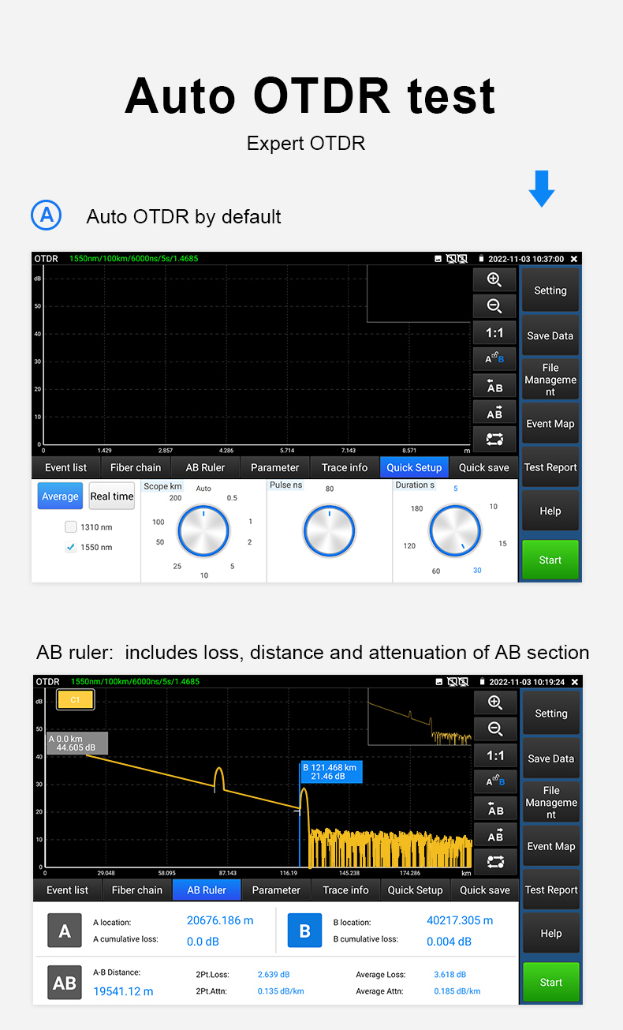

Multi-functional OTDR and measuring instrument
- 8 inch IPS touch screen, 1920*1200 resolution
- 4K H.265 & H.264 IP camera tester
- 4 core CPU, support online update and install applications
- Internal storage and external TF card
- Report saved as EXCEL, PDF, or screenshots format etc
- ONE Gigabit SFP port, support insert SFP optical fiber module,

for optical fiber network testing
- Support snap shot screen
- Support remote control
- 8MP TVI CVI AHD camera testing * Optional
- HDMI input/VGA input * Optional
- DC24V 2A/12V 3A / USB5V2A power output
- Gigabit network port, support Ping and scan IP address etc
- RJ45 TDR cable’s short and open test
- Improvement cable tester, UTP cable etc continuity test
- PoE power output and PoE voltage and power measurement
- Stable laser source, optical power meter and visual fault locator.

Application
aWI-FI

OTDR

Multi-function MT-8500 OTDR series is an essential tool for fiber length, network and camera testing. OTDR displays the power of the returned signal related to distance. The information can be used to confirm the transmission quality of a fiber optic link. It is widely used in the maintenance, construction and monitoring of cable line. It can measure the optical fiber length, transmission attenuation of optical fiber, attenuation of splice, and failure location, etc. as well, built in camera tester for maintenance and installation of IP analog, HD coaxial cameras as well as other security equipment. If taking the all in one OTDR, it will make working conditions safer and increasing productivity.

● CCTV system installation and maintenance
● Network cabling project installation and maintenance
● Dome camera, TVI CVI AHD 4K H.265 IP camera testing
● Video transmission channel testing
● PTZ controller
● Fiber length testing and Event Map etc

Features

MT-8500 series OTDR
OTDR
● 8 inch IPS touch screen, 1920*1200 resolutions
● 1310/1550/1610 wavelength optional, 26/28/30/32/34dB Dynamic range optional, max test range 150KM*
● Stable laser source, support CW/270/330/1000/2000Hz
● Test fiber’s length, loss, attenuation parameters and event map, locate connection point/ fusion point
● Automatic analysis of various linkers/fusion points, easy analyze of various events
● Save and view the testing curves, support zoom and move curves, view details
● Support saving curves number ≥30000pcs
● Support create testing report, curve trajectory graphs, parameter settings, fiber event information, and fiber link information
● Report saved as EXCEL, PDF, or screenshots format etc
● Optical Loss test, detect the optical or optical components loss value .It is a key basic function for confirming the optic fiber installation condition and fault status. Light source shares with OTDR ports outputs laser light.
● Visual Fault Locator, it Outputs red light for checking continuity of launch fibers or short patch cord. Breaks and bending in fiber can be identified visually.
● Stable Laser Source, it shares OTDR optical port and work on the same working wavelength of OTDR, the output power can be adjustable for different testing applications. With modulated light at 270Hz/330Hz/1 kHz/2kHz, it can be used for fiber identification or continuity check purpose on a live fiber network.
● Optical power meter with five wavelength 1625nm,1550nm, 1490nm, 1310nm,1300nm, 850nm, linear or nonlinear optical power display, both for optical power testing and Fiber link loss relative measurement.
● Digital multimeter, DC and AC voltage measurement, Resistance measurement, Continuity test, Diode measurements, Capacitance measurement
Camera testing
● 4K H.265 video display via mainstream
● TVI 4.0/ CVI 5.0/ AHD 4.0 camera test, UTC control & call OSD menu（Only for Model 8510）*
● AXIS, Hikvision, dahua camera testing, enter ONVIF app, input username and password to test
●4K color bar generator, send CVI/TVI/AHD/CVBS color bar video signal for testing monitor or video cable, support 4K resolution（Only for Model 8510）*
● DC12V/3A power output, support temporarily supply power for the camera
● 48V PoE power output,max 30W
● Chrome browser, test and set Axis camera
● Support CVI Audio testing (Only for model MT-8510) *
● Rapid video, just by one key to detect all network cameras and auto display
● Built in Wi-Fi, display image from the wireless camera, create WIFI hotspot
● 4K HDMI input Optional （Only for model MT-8510）*
● 2K 60F VGA input Optional（Only for model MT-8510）*

Cable test:
● Improvement cable tester, UTP cable, telephone cable etc sequence and continuity test, save testing report. Support detect the near-end, mid-end and far-end fault point of the RJ45 cable plug
● Upgraded RJ45 cable TDR test, support cable’s open and short testing, max test 180m
● Cable tracer, search BNC cable, network cable and telephone cable from the mess cables

Other functions
●ONE Gigabit SFP port, support insert SFP optical fiber module, for optical fiber network testing
● New Power management file app,to quickly check POE48V, 24V2A, 12V3A power and voltage
● Tester Play: Tester, android version mobile phone and PC display at the same time
● Advanced Network Tool, Scan IP, Route tracking, Socket debugging, ping packet test,DHCP,PPPOE,LLDP
● 7.4V 7800mA Li-ion Battery, 3.5 hours charging, normal working time lasts 11 hours
OTDR Technical Specifications
Wavelength (nm) Optional * | 1310/1550 |  |  |  | 1610
Only support detects optical signal | Support |  |  |  | N/A
Support Active fiber testing | N/A |  |  |  | Support
Dynamic range(dB)² Optional* | 28/26 | 30/28 | 32/30 | 34/32 | 28 | 30 | 32 | 34
Pulse width (ns) | 5,10,20,30,50,80,160,300,500,800,1000,2000,4000,6000,10000,20000
Testing range | ≤150 Km
Event blind zone (m)³ | ≤0.8m
Attenuation blind zone (m)³ | ≤3m
Linearity (dB/dB) | ±0.05 dB/ dB
Loss threshold (dB) | 0.05
Loss resolution ratio (dB) | 0.01
Minimum distance resolution | 0.05
Sampling point(K) | 32-128
Distance uncertainty (m) | ±(1 m + 5×10⁻⁵× distance + sampling interval)
Distance scope (km) | 0.5,1,2,5,10,25,50,100,200
Typical real-time refreshing duration | 1s
File format | SOR standard format/PDF/EXCEL
Measurement duration | 5sec, 10sec, 15sec, 30sec, 1min, 2min, and 3min are selectable
Storage | FLASH (EMMC)8G + TF card
Interface type | FC-UPC,SC-UPC
Remarks:
1. The technical specification describes the ensured performance of the instrument when using typical PC model connector to measure, without considering the uncertainty caused by optical fiber refractivity.
2. Dynamic range is the data measured under the condition of the maximum pulse width and 3 minutes of average time. Dynamic range is the data measured under the condition of 200km/20000ns/3min.
3. Measuring conditions of blind zone: reflection event is within 5Km, reflection strength is 45dB. Measured by the minimum pulse width.
Specifications

MT-8500 series OTDR
Specification
Size & Display | 8 inch IPS touch screen ,1920*1200 resolution
Network Port | Dual 1000M LAN port, 10/100/1000M auto adapt
WIFI | Built in 2.4G WIFI, speeds150M, display wireless camera image
ONE Gigabit SFP port | support insert SFP optical fiber module, for optical fiber network testing
H.265 mainstream test | H.265 & H .264 IP, 4K video display via mainstream
IP camera test | Support 500 brands IP camera test
IP discovery | Auto-scan the whole network segment IP address
HD coaxial camera test | TVI 4.0/ CVI 5.0/ AHD 4.0 camera test, UTC control & call OSD menu (Only for model MT-8510) *
CVBS camera test | 1 channel BNC input & 1 channel BNC looped output, NTSC/PAL (Auto adapt) (Only for model MT-8510) *
Zoom Image | 4x zoom, enlarge image, screen snapshot, save, view and record and playback
RJ45 cable TDR test | For UTP cable’s open and short test ,max 180M
HDMI input | HDMI input (Only for model MT-8510) *
VGA input | Support 1280x1024/960/800/768/720P 60FPS, 1152x870P 60FPS, 1024x768P 60FPS, 800x600P 60FPS, 640x480P 60FPS resolution (Only for model MT-8510) *
TDR cable test * Optional | For BNC cable, network cable, telephone cable, RVV cable and cat 5/6 cable’s length and short circuit, Max 1.2KM *
Built in Camera * Optional | Built in Camera function Customizable ,support 13MP *
Laser distance meter* Optional | Measurement range100m, accuracy±3mm,Laser class 2,Laser type 635nm,Power output <1mW Customizable *
Digital Multimeter | DC and AC voltage measurement, Resistance measurement, Continuity test, Diode measurements, Capacitance measurement
Power output | 24V2A/ 12V 3A / 5V 2A power output
PoE power output | 48V PoE power output, Max support 30W
UTP cable test | Test UTP cable connection status and display on the screen. Read the number on the screen. detect the near-end, mid-end and far-end fault point of RJ45 cable connector, can test shield cable
RJ45 TDR cable test | Support cable’s open and short testing, max 180m
Data monitor | Captures and analyzes the command data from controlling device, also can send hexadecimal
Network test | Trace route, Link monitor, DHCP server, port flashing, Ping test
Digital Cable tracer | Search BNC cable, network cable and telephone cable from the mess cables. Cable tracer and UTP cable test app in the same interface, also can search shield cable
Electroscope | Voltage range | AC12-1000V
Electroscope | Frequency | 50/60Hz
Electroscope | Alarm type | Sounds and light double alarms
Electroscope | Level | CAT.III 1000V / CAT.IV 600V;CE
PoE Voltage test | Measurement POE switch or PSE power supply voltage and cable connection status
Visual fault locator | 10mW visual fault locator with 650nm wavelength, emit red laser sources to test multi-mode and single mode fiber’s bending and breakage, test range 8KM
Digital Multi-meter | DC and AC voltage measurement, Resistance measurement, Continuity test, Diode measurements, Capacitance measurement
Optical power meter | Wavelength:1625,1550nm,1490nm,1310nm,1300nm,850nm, measurement range ,-70 ～ +10 dBm, for optical power testing and Fiber link loss relative measurement
Power
External power supply | DC 12V（2A）
Battery | Built-in 7.4V Li-ion battery, 7800mAh
Rechargeable | After charging 3.5 hours, normal working time 11 hours
Parameter
Operation setting | OSD menu, select your desired language: English, Portuguese, Korean, Russian, Italian, French, Polish, Spanish, Japanese, Turkish, Deutsch, Serbian, Czech, Vietnamese etc
Auto off | 5-30 (mins)
Working environment
Working Temperature | -10℃---+50℃
Working Humidity | 30%-90%
Dimension/Weight | 274mmX171mmX50mm / 1.2Kg

Note:“*”sign means functions are customizable！The data above is only for reference and any change of them will not be informed in advance. For more detailed technical inquiries, please feel free to contact us
Comparison Table

Feature/Model | MT-8500 | MT-8510 | MT-8800 | MT-8810
Analog camera test | x | √ | x | √
IP camera testing | 4K | 4K | 8K | 8K
8MP AHD/CVI/TVI camera test | x | √ | x | √
WIFI | W Support 2.4G | WIFI Support 2.4G | WIFI Support 2.4/5G | WIFI Support 2.4/5G
Stable laser sources | √ | √ | √ | √
OPM/VFL/DMM | √ | √ | √ | √
Cable tracer/ network tool | √ | √ | √ | √
VGA input | x | √ | x | √
HDMI input | x | √ | x | √
HDMI out | x | x | √ | √
Interface type | FC/SC-UPC | FC/SC-UPC | FC/SC-UPC | FC/SC-UPC
4K color bar output | x | √ | x | √
LAN port | Dual LAN port | Dual LAN port | Dual LAN port | Dual LAN port
Built in Camera * | Customizable (13MP) | Customizable (13MP) | Customizable （5MP） | Customizable (5MP)
Laser distance meter* | Customizable | Customizable | Customizable | Customizable
TDR cable test ,max 1.2KM * | Customizable | Customizable | Customizable | Customizable
RJ45 TDR cable test, Support cable ‘s open and shorts test ,max 180m | √ | √ | √ | √

