WANGLU Professional Multi-Function OTDR/MOT-65

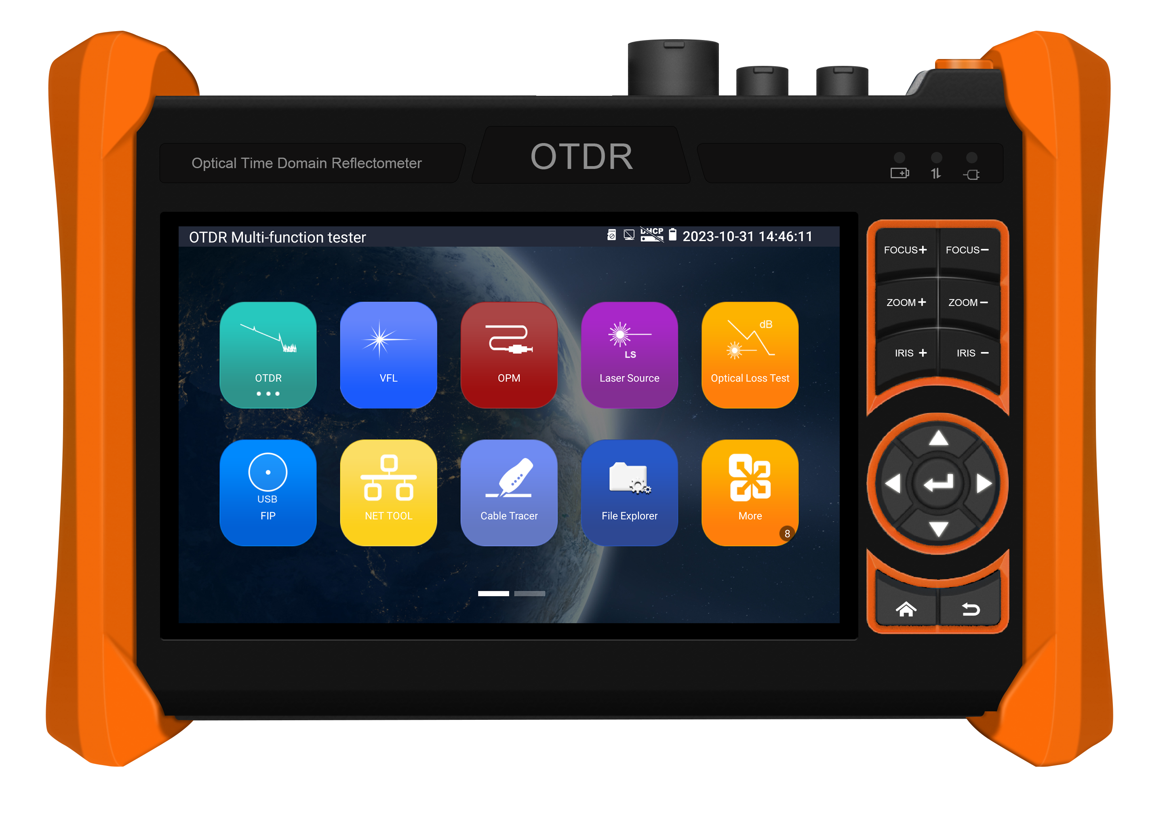

Professional Multi-Function OTDR with
Network tool and cable testing


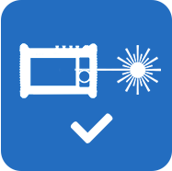
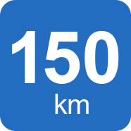
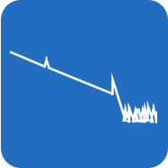


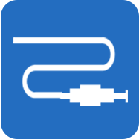
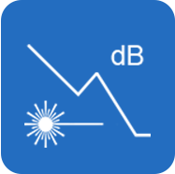


LPDDR4

Stable laser source
Optical signal

OPM
OTDR testing
WIFI
VFL
Max 150KM
Optical loss test









POE detection
Cable tracer
FTP
Network tool
Cable length
UTP cable test
4 core CPU

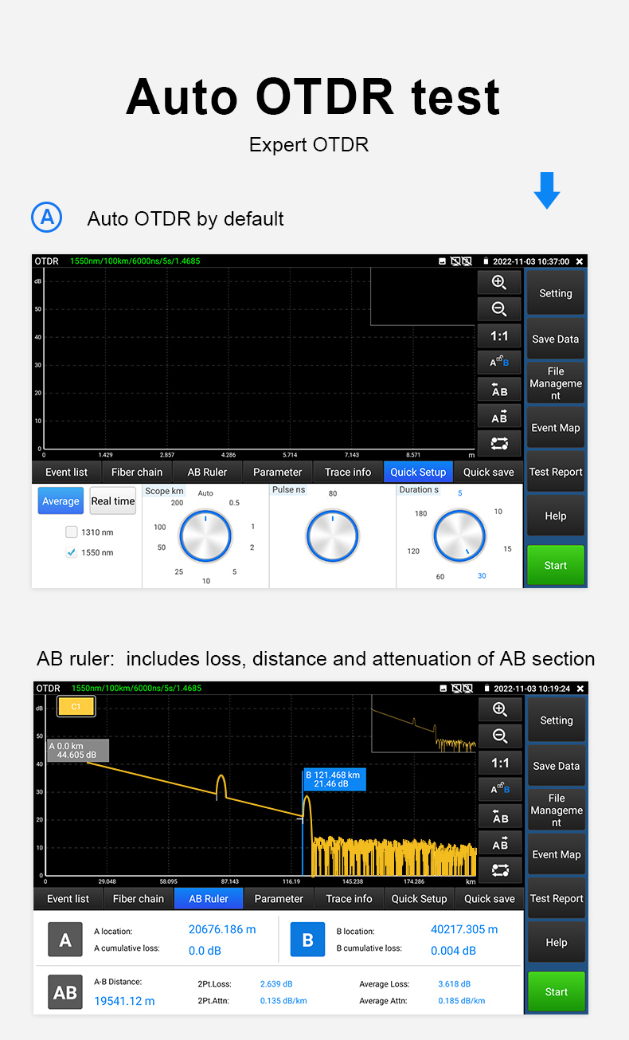

Multi-functional OTDR and measuring instrument
- 5.4 inch IPS touch screen, 1920*1152 resolution
- 4 core CPU, support online update and install applications
- Internal storage and external TF card
- Report saved as EXCEL, PDF, or screenshots format etc
- Support snap shot screen
- Support remote control
- 5V 2A power output, as power bank
- One Gigabit network port, support Ping and scan IP address etc
- Wifi Analyzer, create wifi hotspot
- RJ45 TDR cable’s status and length, max 600meter
- Cable length, the max length up to 3km
- Improvement cable tester, UTP cable etc continuity test
- PoE supply power detection and PoE voltage and power measurement
- Stable laser source, optical power meter and visual fault locator

Application
aWI-FI

OTDR

Multi-function MOT-65 OTDR series is an essential tool for fiber length and network testing. OTDR displays the power of the returned signal related to distance. The information can be used to confirm the transmission quality of a fiber optic link. It is widely used in the maintenance, construction and monitoring of cable line. It can measure the optical fiber length, transmission attenuation of optical fiber, attenuation of splice, and failure location, etc. If taking the all in one OTDR, it will make working conditions safer and increasing productivity.

● Fiber length testing and Event Map etc
● PING Test, IP Scan, Port flashing and WIFI
● Network cabling project installation and maintenance

WANGLU Professional Multi-Function OTDR/MOT-65

Features

OTDR
● 5.4 inch IPS touch screen, 1920*1152 resolutions
● 1310/1550/1610 wavelength optional, 26/28/30/32/34dB Dynamic range optional, max test range 150KM*
● Stable laser source, support CW/270/330/1000/2000Hz
● Test fiber’s length, loss, attenuation parameters and event map, locate connection point/ fusion point
● Automatic analysis of various linkers/fusion points, easy analyze of various events
● Save and view the testing curves, support zoom and move curves, view details
● Support saving curves number ≥30000pcs
● Support create testing report, curve trajectory graphs, parameter settings, fiber event information, and fiber link information
● Report saved as EXCEL, PDF, or screenshots format etc
● Optical Loss test, detect the optical or optical components loss value .It is a key basic function for confirming the optic fiber installation condition and fault status. Light source shares with OTDR ports outputs laser light.
● Visual Fault Locator, it Outputs red light for checking continuity of launch fibers or short patch cord. Breaks and bending in fiber can be identified visually.
● Stable Laser Source, it shares OTDR optical port and work on the same working wavelength of OTDR, the output power can be adjustable for different testing applications. With modulated light at 270Hz/330Hz/1 kHz/2kHz, it can be used for fiber identification or continuity check purpose on a live fiber network.
● Optical power meter with five wavelength 1625nm,1550nm, 1490nm, 1310nm,1300nm, 850nm, linear or nonlinear optical power display, both for optical power testing and Fiber link loss relative measurement.

Cable test:
● Improvement cable tester, UTP cable, telephone cable etc sequence and continuity test, save testing report. Support detect the near-end, mid-end and far-end fault point of the RJ45 cable plug
● Upgraded RJ45 cable TDR test, support cable status and length, max test 600m
● Cable tracer, search BNC cable, network cable and telephone cable from the mess cables
● Cable length, BNC cable, network cable, telephone cable, RVV cable, elevator cable, and cat 5/6 cable’s length test. Max measurement for cable’s open is 3KM* (Short circuit length test not supported) *
Other functions
● Tester Play: Tester, android version mobile phone and PC display at the same time
● Network tool, Ping test, IP scan, PPPOE, Port flashing,etc.
● 7.4V 5200mA Li-ion Battery, 2.5 hours charging, normal working time lasts 11 hours

WANGLU Professional Multi-Function OTDR/MOT-65

Specifications

OTDR Technical Specifications
Wavelength (nm) Optional * | 1310/1550 |  |  |  | 1610
Only support detects optical signal | Support |  |  |  | N/A
Support Active fiber testing | N/A |  |  |  | Support
Dynamic range(dB)² Optional* | 28/26 | 30/28 | 32/30 | 34/32 | 28 | 30 | 32
Pulse width (ns) | 5,10,20,30,50,80,160,300,500,800,1000,2000,4000,6000,10000,20000
Testing range | ≤150 Km
Event blind zone (m)³ | ≤0.8m
Attenuation blind zone (m)³ | ≤3m
Linearity (dB/dB) | ±0.05 dB/ dB
Loss threshold (dB) | 0.05
Loss resolution ratio (dB) | 0.01
Minimum distance resolution | 0.03
Sampling point(K) | 32-128
Distance uncertainty (m) | ±(1 m + 5×10⁻⁵× distance + sampling interval)
Distance scope (km) | 0.1,0.5,1,2,5,10,25,60,120,180,260
Typical real-time refreshing duration | 1s
File format | SOR standard format/PDF/EXCEL
Measurement duration | 5sec, 10sec, 15sec, 30sec, 1min, 2min, and 3min are selectable
Storage | FLASH (EMMC)8G + TF card (NOT Included )
Interface type | SC-UPC
Remarks:
1. The technical specification describes the ensured performance of the instrument when using typical PC model connector to measure, without considering the uncertainty caused by optical fiber refractivity.
2. Dynamic range is the data measured under the condition of the maximum pulse width and 3 minutes of average time. Dynamic range is the data measured under the condition of 200km/20000ns/3min.
3. Measuring conditions of blind zone: reflection event is within 5Km, reflection strength is 45dB. Measured by the minimum pulse width.
4. TF card not included

Specification
Size & Display |  | 5.4 inch IPS touch screen ,1920*1152 resolution
Network Port |  | 1000M LAN port, 10/100/1000M auto adapt
WIFI |  | Built in 2.4G WIFI, speeds150M
Power output |  | 5V 2A power output, as power bank
PoE detection |  | Display the standard PoE or Non-standard PoE, PoE voltage and cable connection status
UTP cable test |  | Test UTP cable connection status and display on the screen. Read the number on the screen. detect the near-end, mid-end and far-end fault point of RJ45 cable connector, can test shield cable
RJ45 TDR cable test |  | Support cable status and length, max 600m
Data monitor |  | Captures and analyzes the command data from controlling device, also can send hexadecimal
Network test |  | Trace route, Link monitor, DHCP server, port flashing, Ping test
Digital Cable tracer |  | Search BNC cable, network cable and telephone cable from the mess cables. Cable tracer and UTP cable test app in the same interface, also can search shield cable
Electroscope |  | Voltage range | AC12-1000V
 |  | Frequency | 50/60Hz
 |  | Alarm type | Sounds and light double alarms
 |  | Level | CAT.III 1000V / CAT.IV 600V;CE
Visual fault locator |  | 10mW visual fault locator with 650nm wavelength, emit red laser sources to test multi-mode and single mode fiber’s bending and breakage, test range 8KM
Optical power meter |  | Wavelength:1625,1550nm,1490nm,1310nm,1300nm,850nm, measurement range ,-70 ～ +10 dBm, for optical power testing and Fiber link loss relative measurement
Laser source parameter
Laser type | FP-LD
Output wavelength | 1310/1550 |  |  | 1610
Output power | -5dBm~0dBm
Frequency | 270Hz/330Hz/1kHz/2kHz
Stability | CW，土0.2dB/15min (Test after boot for 15min)
Power
External power supply |  | DC 12V（1A）
Battery |  | Built-in 7.4V Li-ion battery, 5200mAh
Rechargeable |  | After charging 2.5 hours, normal working time 11 hours
Parameter
Operation setting |  | OSD menu, select your desired language: English, Portuguese, Korean, Russian, Italian, French, Polish, Spanish, Japanese, Turkish, Deutsch, Serbian, Czech, Vietnamese etc
Auto off |  | 5-30 (mins)
Working environment
Working Temperature |  | -10℃---+50℃
Working Humidity |  | 30%-90%
Dimension/Weight |  | 203mmX141mmX46mm / 0.92Kg

