
Multi-functions CCTV Tester TECHNOLOGY

IPC-9800ADH Pro︱8K IP Camera Tester
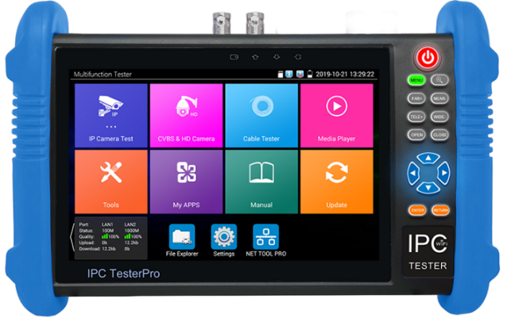
7 Inch All-in-one CCTV Tester
7 inch IPS touch screen, 1280*800 resolution
8K H.265 video display via mainstream
8MP CVI/TVI/AHD camera test
Dahua, Hikvision, Axis etc ONVIF camera test
HDMI input 4K 30FPS, HDMI output 4K 60FPS
VGA input support 1920*1080P
DC24V 2A, DC12V 3A power output
PoE++ power output, max power 90W
SFP Optical module port
Brand new dual gigabit Ethernet ports
UTP cable test/RJ45 cable TDR test, cable quality test



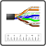

TesterPlay, support remote control and voice intercom
Backlight buttons, easier to operate in the dark
Application

The 7 inch IPS touch screen IP camera tester is designed for maintenance and installation of IP analog, HD coaxial cameras as well as other security equipment. The 1280x800 resolution enables it to display network HD cameras and analog cameras in high resolution. The unit supports many ONVIF PTZ and analog PTZ control. Additionally, it with other functions TDR cable test, Digital multi-meter, UTP cable test and cable scan etc. CCTV installers often need to carry a variety of testing tools to complete their work. If take the all in one camera tester, making working conditions safer and increasing productivity.
CCTV system installation and maintenance
Network cabling project installation and maintenance
Dome camera, IP TVI CVI AHD 8K H.265 camera testing
Video transmission channel testing
PTZ controller

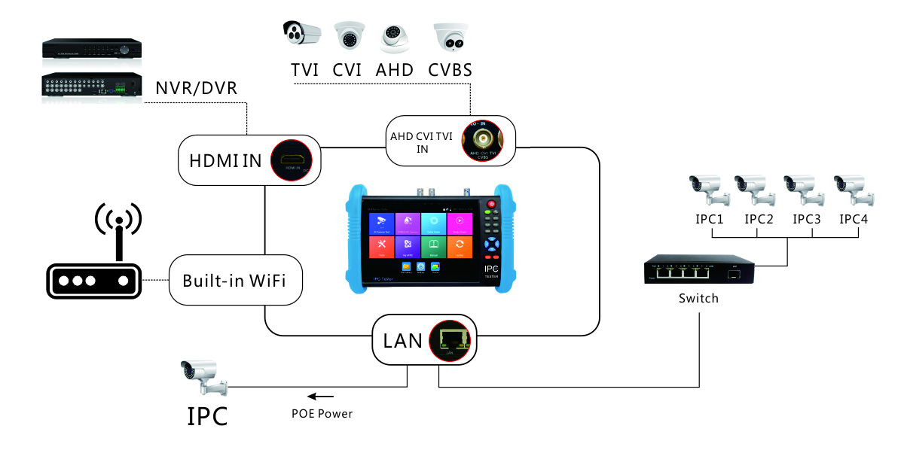

Features

Camera test:
● 7 inch IPS touch screen, 1280*800 resolution
● 8K H.265 video display via mainstream
● 8MP TVI test,3840 x 2160P 15 FPS, 4xzoom, video record & playback, coaxial PTZ control & call OSD menu
● 8MP AHD test, 3840 x 2160P 15 FPS,4xzoom, video record & playback, coaxial PTZ & call OSD menu
● 8MP CVI test, 3840 x 2160P 12.5/15 FPS, 4xzoom, video record & playback, coaxial PTZ & call OSD menu
● Rapid ONVIF, Auto log in and display image, create testing report
● AXIS, Hikvision camera test, enter ONVIF app, input username and password to test
● CVBS camera test and PTZ control
● IPC TEST (Non-ONVIF test), HIK test tool (Hikvision camera), DH test tool (Dahua camera)
● DC24V 2A, DC12V 3A power output, camera can be powered from tester
● 55V PoE++ power output power, max power 90W
● Rapid video, just by one key to detect all network cameras and auto display
● Built in Wi-Fi, display image from the wireless camera, create WIFI hotspot
● CVBS loop test, the tester can send and receive color bar generator signal, to check BNC cable
● Enhanced Color bar generator, PAL/NTSC multi-system color bar video generator
Cable test:
● Improvement cable tester, UTP cable, telephone cable etc order and connectivity test, can save testing report, if special number, need customized
● RJ45 cable TDR test, test cable pair status, length, attenuation, reflectivity, impedance, skew etc
Other functions:
● Professional WIFI Analyzer, detect the surrounding wifi signal and signal strength
● Network tool: Ping, IP scan, Port Flash, DHCP server, Trace Route
● POE & power information, DC12V& PoE power and voltage output /input measurement
● TesterPlay: Tester, android version mobile phone and PC display at the same time
● Shortcut button, drop-down menu, can select Poe power, IP setting, CVBS, LAN info, HDMI IN etc
● HDMI input support 4K 30FPS, HDMI output support 4K 60FPS
VGA input support 1920*1080P
● Traffic monitoring, display network port or WIFI connection real-time upload and download speeds and other network parameters
● Self-update software, you can install apps with android version
● Media player, 4K video files and MKV/MP4 media files play
● Quick office, quick office app (support excel, word, ppt format) doc. editable
● 8GB SD card included
● Audio in, support record and save the audio/LED lamp, calculators, music players and other application tools
● 11.1 V /5200mAh Lithium Ion Battery, after 3.5 hours fast charging, working time lasts 11 hours

Specifications

LCD | Item series | IPC-9800ADH Pro
LCD | Display | New 7 inch IPS touch screen, 1280*800 resolution
Video Mode | CVBS | 1 channel BNC input & 1 channel BNC looped output, NTSC/PAL (Auto adapt)
Video Mode | CVBS | HD coaxial video level meter, peak video signal level, SYNC signal level, Color bar chroma level measurement
Video Mode | CVBS | PTZ control, RS485 control, Baud 600-115200bps, compatible with more than 30 protocols such as PELCO-D/P, Samsung, Panasonic etc
Video Mode | CVBS | CVBS loop test | The tester can send and receive color bar generator signal to check BNC cable
Video Mode | IP camera test  8K/H.265/H.264 | IP Discovery/Quick ONVIF/IPC test /RTSP play /Client APK
Video Mode | IP camera test  8K/H.265/H.264 | Rapid Video | Auto view the video, create testing report
Video Mode | IP camera test  8K/H.265/H.264 | Hik test tool | Activate Hikvision camera, modify the user name, password and IP parameters
Video Mode | IP camera test  8K/H.265/H.264 | Dahua test tool | Dahua camera test, modify the user name, password and IP parameters
Video Mode | IP & CVBS test | IP & CVBS test at the same time, converter test from analog to digital with dual test window
Video Mode | Coaxial HD test | 8MP TVI camera test, 3840 x 2160P 15 FPS, UTC control & call OSD menu
Video Mode | Coaxial HD test | 8MP CVI camera test, 3840 x 2160P 12.5/15 FPS, UTC control & call OSD menu
Video Mode | Coaxial HD test | 8MP AHD test, 3840 x 2160P 12.5/15 FPS, UTC control & call OSD menu
Video Mode | HDMI in & out | Support HDMI input 4K 30FPS, HDMI output 4K 60FPS
Video Mode | VGA input | Support 1920*1080P
Video Mode | Zoom Image | 4x zoom, to enlarge image, Screen snapshot, record, save, view and record and play back
Analog Video out | Color bar generator | Output one channel PAL/NTSC color bar video signal for testing monitor or video cable
Power output | PoE++ power output | 55V PoE++ power output, max power 90W
Power output | DC24 V power | DC24V 2A power output
Power output | DC12V power | DC12V 3A power output
 | DC5V Power | DC5V 2A power output
 | UTP cable test | Test UTP cable connection status and display on the screen. Read the number on the screen
 | RJ45 cable TDR test | Test cable pair status, length, attenuation, reflectivity, impedance, skew etc. measurement range 180M
TesterPlay | Screen projection: Tester, mobile phone and PC display at the same time (For android version mobile phone)
Network test | Trace route, Link monitor, DHCP server, port flashing, Ping test
Wi-Fi | Built in WIFI, speeds 150M, display wireless camera image
Audio test | 1 channel audio signal input, test whether sound normal, 1 channel audio signal, to connect headphone
Data monitor | Captures and analyzes the command data from controlling device, also can send hexadecimal
PoE test | Measurement PoE switch or PSE power supply voltage and cable connection status
Drop-down menu | You can select PoE power switch, IP setting, CVBS, LAN info, HDMI IN functions etc in any interface
External power supply | DC 15V 1.6A
Battery | Built-in 11.1V Lithium ion battery, 5200mAh
Rechargeable | After fast charging 3.5 hours, normal working time 11 hours
Operation setting | OSD menu, select your desired language: English, Portuguese, Korean, Russian, Italian, French, Polish, Spanish, Japanese, Turkish, Deutsch, Serbian, Czech, Vietnamese etc
Auto off | 1-30 (mins)
Working Temperature | -10℃---+50℃
Working Humidity | 30%-90%
Dimension/Weight | 240mm x 154mm x 46mm / 620g

The data above is only for reference and any change of them will not be informed in advance. For more detailed technical inquiries, please feel free to contact us.
Comparison Table

Features/ Model | IPC-9800 Pro | IPC-9800ADH Pro | IPC-9800ADHS Pro | IPC-9800CLMOVTADHS Pro
IP & CVBS | √ | √ | √ | √
HDMI INPUT * | X | √ | √ | √
VGA INPUT* | X | √ | √ | √
Video level meter* | X | X | X | √
Digital cable tracer* | X | X | X | √
Digital multimeter* | X | X | X | √
Optical power meter* | X | X | X | √
Visual fault locator* | X | X | X | √
Cable length* | X | √ | √ | √
TDR cable test* | X | X | X | √
BNC attenuation test | X | X | X | √
8MP AHD* | X | √ | √ | √
8MP CVI* | X | √ | √ | √
8MP TVI* | X | √ | √ | √
8MP EX-SDI, HD-SDI, 3G-SDI * | X | X | √ | √

Packing kits

1) Tester
2) Network cable tester
3) Adaptor DC15V 1.6A/ 8GB SD card
4) Polymer lithium-ion battery (11.1V DC 5200mAh)
5) Tool bag / DC Power cable/BNC cable/ RS485 cable/ Audio cable/ Safety cord
9) Manual

