
Multi-functions Wire Tracker TECHNOLOGY

CT-66︱Wire tracker
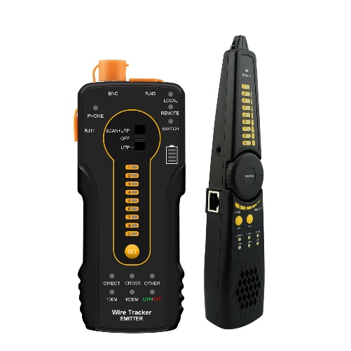
Multi-functions Wire Tracker
● Cable tracer, can search UTP cable, BNC cable from mess cable
● Identify cable type:100M/1000M, straight/cross/other.
● UTP/STP/RJ45/RJ11 cable scan and continuity testing
● UTP port support max 60V withstand voltage
● Identify the status in the working telephone line: standby, ringing and off-hook
● PD powered detection: detect whether the power output of the POE switch is normal, and detect the pins used for power supply.

Application

The multifunction Wire Tracker is designed for maintenance and installation of cable, cable tracer in one equipment. The unit supports detect the near-end, mid-end and far-end fault point of RJ45 cable connector. UTP port support max 60V withstand voltage, the wire can be traced directly in connection with PoE switch. Installers and engineers take the all in one cable tester, making working conditions safer and increasing productivity.

● Network cabling project installation and maintenance
● Computer room detection and maintenance
● CCTV system installation

Features

● Secondary code digital mode, decisively rejects noise and false signals, locate cables quickly and easily.
● Cable tracer and UTP cable test at the same time.
● Identify cable type:100M/1000M, straight/cross/other.
● UTP/STP/RJ45/RJ11 cable scan and continuity testing.
● Identify the status in the working telephone line: standby, ringing and off-hook
● Quickly detect the near-end, mid-end and far-end fault point of RJ45 cable connector
● UTP port support max 60V withstand voltage, the wire can be traced directly in connection with PoE switch
● Shielded cable and shielding layer continuity test
● Detect the short circuit of cable NEW
● Detect the link continuity of the switch port NEW
● PD powered detection: detect whether the power output of the POE switch is normal,
and detect the pins used for power supply.
● Support silent mode
● Two bright LED lights for working in the dark
Specifications

Item | Wire Tracker CT-66
Emit signal | Digital signal（rejects noise and false signals ）
Cable type | RJ45 Twisted pair, RJ11 telephone line, BNC cable etc.
UTP cable test | The digital “1-8” for cable sequence shielded cable and shielding layer continuity indicator, check cable type indicator: straight/cross/other, 100M/1000M Network cable test, and near-end, mid-end, far-end continuity testing
Continuity test of RJ45 cable connectors | Check wire continuity of both RJ45 cable connector
PD (powered) test | PoE switch power supplying status test and check the pins used for power supply.
LED lamp | Short press ON /OFF LED Light
Silent mode | Long press key “Mute” to switch silent mode, find cable through indicator
Audio output | Support external audio output
Power supply
External power supply | Two AA battery
General
Working Temperature | -10℃---+50℃
Working Humidity | 30%-90%
Dimension
Emitter Dimension | 152mm x 62mm x 27mm /0.12KG
Receiver Dimension | 218mm x 48mm x 32mm /0.1KG
The data above is only for reference and any change of them will not be informed in advance. For more detailed technical inquiries, please feel free to contact us.
Packing kits

1) Wire tracker emitter
2) Wire receiver
3) RJ45 cable
4) BNC alligator clip cable
5) Manual

