48GE+4SFP L2 400W POE Switch

SC-514804MPUW400

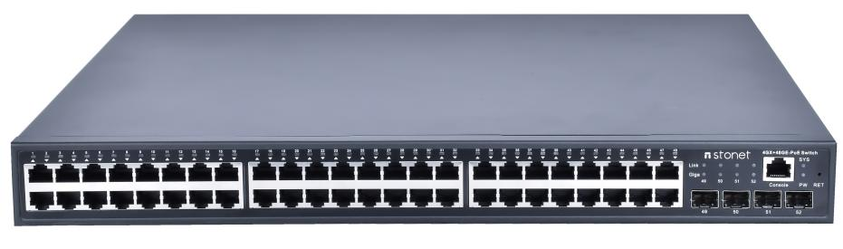
SC-514804MPUW400 is a L2 POE switch independently developed by our company，It has 4*1000Base-X SFP，48*100/1000M POE port, PoE Ethernet switches support the IEEE802.3af/at power over Ethernet standard and use advanced self sensing algorithms to automatically detect PD powered devices in the network. They only provide power to terminal devices that support the IEEE802.3af/at power over Ethernet standard, without worrying about damaging private standard PoE or non PoE devices. Automatically identify PoE requirements, speed, working mode, and type of Ethernet cable used, simple and convenient to use, supporting various business functions such as routing, multicast, VLAN, QoS, etc. And with a comprehensive security control strategy and network protection mechanism, it can be used as an aggregation layer switch and is an ideal choice for various commercial network applications. Well developed multicast protocol, supporting IGMP Snooping/MLD Snooping， Meet the demand for high-definition video surveillance and video conferencing across multiple terminals. And it holds functions such as routing, DHCP Server, QoS, ACL, etc., to meet the network building needs of households, enterprises, hotels, etc.
This product is compatible with all mainstream cameras in the market and widely used in enterprise network convergence layers. It is compatible with computers, printers, network cameras, wireless APs, and can be extended to multimedia transmission systems, wireless network transmission, industry broadband specialized networks, etc; And it is suitable for data transmission fields such as enterprises, security, transportation, power and electricity, mining industry, water and oil, small enterprises, bars, hotels, and schools, with a wide range of scenarios.

Product Features

- Compliant with IEEE 802.3, IEEE 802.3u, IEEE 802.3ab, IEEE 802.3z standards
- Each port supports full-duplex 802.3x flow control and half-duplex backpressure flow control
- 4*1000M SFP, 48*1000M POE port
- Supports standard IEEE 802.3af/at protocol, single port 15.4W/30W output
- All ports support half/full duplex mode automatic adaptation
- Support port mirroring, support SNTP protocol
- Support for MAC filtering, MAC address binding, 802.1X authentication
- Storage-forwarding switching mode
- Flow control switch, turn on or off flow control function
- Supporting MAC Address Self-learning
- 0～55°C operating temperature range
- AC 220 power supply, flexible input
- Dynamic LED indicator showing device operating status and providing simple troubleshooting
Strong compatibility
4*1000M SFP, 48*1000M POE port, Auto MDIMDIX,It can integrate 10 Mbps, 100 Mbps, 1000 Mbps network devices in the same network perfectly.
Excellent performance
1Gigabit ports can automatically adapt to full-duplex or half-duplex mode.Can achieve a bidirectional transfer rate of up to 2000Mbps per port，Increase bandwidth and reduce access latency for connections between clients, truly meeting the needs of sharing high-bandwidth multimedia files, videos or other high-speed applications on the network;
MAC address self-learning function to ensure data-free transmission；
Store-and-forward switching mode to prevent damaged packets from spreading across the network；
The flow control function can prevent the impact of instantaneous large amount of data on the network and ensure the efficient and stable operation of your network.
Plug and play
The product is a management switch, and it can work normally without any configuration when it is used；
Each port supports Auto-MDI/MDIX auto-flip function, so you no longer have to worry about cable type.
Convenient maintenance
The LED indicator lamp on the front panel of the switch can dynamically display the connection and operation status of the equipment, and provide a simple fault detection method for easy maintenance.
Specifications | Parameter
switching capacity | 128Gbps
Packet forwarding rate | 132Mpps
Processor | Dual-Core ARM Cortex A9 processor
Memory | 1016 MHz 1 GB DDR3 SD RAM memory
MAC table entry | 8K
Buffer value | 4M
Jitter delay | 9.62ns
Size | 440mm × 265mm × 45mm
weight | 5kg
Power | 400W
working temperature | 0~55°C
Storage temperature | -10~70°C
Working humidity | 10%～90% no condensation
Storage humidity | 5%～95% no condensation
VLAN | Maximum support for 4096 VLANs
VLAN | Support port-based VLAN
VLAN | VLAN Supporting 802.1Q Standard
spanning tree | Support RSTP Fast Spanning Tree Protocol
Ring network | Supporting Fast Loop Networks
Erps | support
Route | Static Route, OSPF
Port aggregation | Support static aggregation
Port mirroring | Support multi-to-one port mirroring without restriction on the number of mirror source ports
Loop Guard | Supporting Loop Detection/Loop Avoidance
Port flow control | Supporting half-duplex control based on backpressure
line rate | Support port-based input/output bandwidth management
IGMP Snooping | Support IGMP Snooping
DHCP | Support DHCP Client
Storm suppression | Supporting suppression of broadcasting, multicast, unicast, etc
Negotiation mode | Support port auto-negotiation (self-negotiation transmission rate and duplex mode)
system maintenance | Supporting profile upload/download
system maintenance | Support upgrade package upload
system maintenance | Support WEB to restore factory configuration
system maintenance | Support System Logging Function
Network management | Support WEB interface management, CONSOLE,Telnet

