8xSFP/16xGE Bakır Yönetilmez Switch
SC-511608U
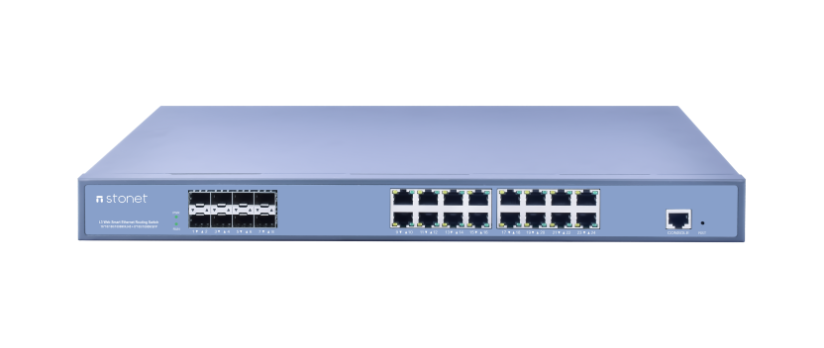
SC-511608U is the company dedicated to the working group, cafes, schools, security monitoring aggregation, small and medium enterprises to upgrade to gigabit LAN and high bandwidth to meet their needs and design of unmanaged Gigabit Ethernet Switching Products. It provides8*1000M SFP port, 16*10/100/1000M adaptive RJ45 port, all ports support full wire-speed non-blocking switching and port auto-flip function, shape with standard 19-inch rack design.

Product Features

Strong compatibility
16 10/100/1000M adaptive port, can be the same network of 10Mbps, 100Mbps or 1000Mbps network devices seamlessly integrated.
Excellent performance
24 1000M ports are able to automatically adapt to full duplex or half duplex mode, can achieve the highest 2000Mbps per port two-way transmission rate, Increase the bandwidth and reduce the access delay for the client, Truly meet the needs of your network to share and transmit high bandwidth multimedia files, games, or other high-speed applications;
MAC address self-learning function, to ensure error-free data transmission;
Store and forward switching mode, prevents damaged packets flooded in the network;
Plug and Play
The switch is a non - managed switch, without any configuration.
Each port supports Auto-MDI/MDIX auto flip function.
Easy maintenance
LED indicators on the front panel, can dynamically display device is connected and operating status, it provides a simple fault detection method, easy to maintain.
Product Features
- Comply with IEEE 802.3, IEEE 802.3u, IEEE 802.3ab, IEEE 802.3z standard
- Each port supports full-duplex 802.3x flow control and half-duplex backpressure flow control
- 16 10/100 / 1000M adaptive RJ45 ports, 8 Gigabit SFP ports
- All ports support half / full duplex mode automatically adapt
- Use storage - forward switching mode
- Support MAC address self-learning
- Dynamic LED indicator to show the state of equipment and provide a simple troubleshooting
- 19 inches steel, standard rack design
Technical Specifications

Standards | IEEE802.3, 802.3u, 802.3ab, 802.3x
Basic Function | Wire-speed Performance
Basic Function | MAC Address Auto-Learning and Auto-aging
Basic Function | IEEE802.3x flow control for Full-Duplex Mode and backpressure for Half-Duplex Mode
switching capacity | 128Gbps
Packet forwarding rate | 132Mpps
Processor | Dual-Core ARM Cortex A9 processor
Memory | 1016 MHz 1 GB DDR3 SD RAM memory
MAC Address | 8k
Buffer value | 4M
Forwarding Rate | 10BASE-T: 14880pps/port  100BASE-TX: 148800pps/port  1000BASE-T: 1488000pps/port
Transmission Method | Store-and-Forward
Ports | 16 10/100/1000Mbps Auto-Negotiation RJ45 ports (Auto MDI/MDIX) and 8 SFP independent expansion slots
Network Media | 10Base-T: UTP category 3, 4, 5 cable (maximum 100m)  EIA/TIA-568 100Ù STP (maximum 100m)  100Base-Tx: UTP category 5, 5e cable (maximum 100m)  EIA/TIA-568 100Ù STP (maximum 100m)  1000Base-T: UTP category 5, 5e cable (maximum 100m)
LED Indicators | Power, Run, 1000M
Dimensions (W*D*H) | 440mm × 265mm × 44mm
Environment | Operating Temperature: 0℃~55℃  Storage Temperature: -10℃~70℃  Operating Humidity: 10%~90% non-condensing  Storage Humidity: 5%~90% non-condensing
Input  Consumption | Power: 100-240V 50-60Hz  Max:30w

