SPT-P13TG-LR(S)
10Gbps SFP+ Optical Transceiver, 10km or 20km Reach
Features

- Optical interface compliant to IEEE 802.3ae 10GBASE-LR
- Electrical interface compliant to SFF-8431
- Hot Pluggable
- 1310nm DFB transmitter, PIN photo-detector
- Operating case temperature: Standard: 0 to +70°C Industrial: -40 to +85°C
- Low power consumption
- Applicable for 10km or 20km SMF connection
- All-metal housing for superior EMI performance
- Advanced firmware allow customer system encryption information to be stored in transceiver
- Cost effective SFP+ solution, enables higher port densities and greater bandwidth
Applications
- 10GBASE-LR/LW Ethernet
- SONET OC-192 / SDH
- 10G Fibre Channel
Product Description
This 1310 nm 10G SFP+ LR transceiver is a very compact 10Gb/s optical transceiver module for serial optical communication applications at 10Gb/s. The SFP+LR converts a 10Gb/s serial electrical data stream to 10Gb/s optical output signal and a 10Gb/s optical input signal to 10Gb/s serial electrical data streams. The high speed 10Gb/s electrical interface is fully compliant with SFI specification.
The high performance 1310nm DFB transmitter and high sensitivity PIN receiver provide superior performance for Ethernet applications at up to 10km or 20km links
The SFP+ Module compliants with SFF-8431, SFF-8432 and IEEE 802.3ae 10GBASE-LR. Digital diagnostics functions are available via a 2-wire serial interface, as specified in SFF-8472.
The fully SFP compliant form factor provides hot pluggability, easy optical port upgrades and low EMI emission.
Absolute Maximum Ratings
These values represent the damage threshold of the module. Stress in excess of any of the individual

Absolute Maximum Ratings can cause immediate catastrophic damage to the module even if all other parameters are within Recommended Operating Conditions.
Parameter | Symbol | Min. | Typical | Max. | Unit
Storage Temperature | TS | -40 |  | +85 | °C
Case Operating Temperature | TA | 0 |  | 70 | °C
Maximum Supply Voltage | Vcc | -0.5 |  | 4 | V
Relative Humidity | RH | 0 |  | 85 | %
Electrical Characteristics (TOP = 0 to 70 °C, VCC = 3.135 to 3.465 )

Parameter | Symbol | Min. | Typical | Max. | Unit | Note
Supply Voltage | Vcc | 3.135 |  | 3.465 | V
Supply Current | Icc |  |  | 300 | mA
Power Consumption | P |  |  | 1.5 | W
Transmitter Section:
Input differential impedance | Rin |  | 100 |  | Ω | 1
Tx Input Single Ended DC Voltage Tolerance (Ref VeeT) | V | -0.3 |  | 4 | V
Differential input voltage swing | Vin,pp | 180 |  | 700 | mV | 2
Transmit Disable Voltage | VD | 2 |  | Vcc | V | 3
Transmit Enable Voltage | VEN | Vee |  | Vee+0.  8 | V
Receiver Section:
Single Ended Output Voltage Tolerance | V | -0.3 |  | 4 | V
Rx Output Diff Voltage | Vo | 180 |  | 850 | mV
Rx Output Rise and Fall Time | Tr/Tf | 30 |  |  | ps | 4
LOS Fault | VLOS fault | 2 |  | VccHOS  T | V | 5
LOS Normal | VLOS norm | Vee |  | Vee+0.  8 | V | 5
Note:
- Connected directly to TX data input pins. AC coupling from pins into laser driver IC.
- Per SFF-8431 Rev 3.0
- Into 100 ohms differential termination. 4.20%～80%
5.LOS is an open collector output. Should be pulled up with 4.7k – 10kΩ on the host board. Normal operation is logic 0; loss of signal is logic 1. Maximum pull-up voltage is 5.5V.

Optical Parameters (TOP = 0 to 70 °C, VCC = 3.135 to 3.465 )

Parameter | Symbol | Min. | Typical | Max. | Unit | Note

Transmitter Section:
Center Wavelength | λt | 1290 | 1310 | 1330 | nm
spectral width | △λ |  |  | 1 | nm
Average Optical Power | Pavg | -8.2 |  | 0.5 | dBm | 1
Optical Power OMA | Poma | -5.2 |  |  | dBm
Laser Off Power | Poff |  |  | -30 | dBm
Extinction Ratio | ER | 3.5 |  |  | dB | 7
Extinction Ratio | ER | 6 |  |  | dB | 6
Transmitter Dispersion Penalty | TDP |  |  | 3.2 | dB | 2
Relative Intensity Noise | Rin |  |  | -128 | dB/Hz | 3
Optical Return Loss Tolerance |  | 20 |  |  | dB
Receiver Section:
Center Wavelength | λr | 1260 |  | 1355 | nm
Receiver Sensitivity | Sen |  |  | -14.5 | dBm | 4,7
Receiver Sensitivity | Sen |  |  | -14.5 | dBm | 4,6
Stressed Sensitivity (OMA) | SenST |  |  | -10.3 | dBm | 4
Los Assert | LOSA | -25 |  | - | dBm
Los Dessert | LOSD |  |  | -15 | dBm
Los Hysteresis | LOSH | 0.5 |  |  | dB
Overload | Sat | 0 |  |  | dBm | 5
Receiver Reflectance | Rrx |  |  | -12 | dB
Note:
- Average power figures are informative only, per IEEE802.3ae.
- TWDP figure requires the host board to be SFF-8431compliant. TWDP is calculated using the Matlab code provided in clause 68.6.6.2 of IEEE802.3ae.
- 12dB reflection.
- Conditions of stressed receiver tests per IEEE802.3ae. CSRS testing requires the host board to be SFF-8431 compliant.
- Receiver overload specified in OMA and under the worst comprehensive stressed condition.
- SONET OC-192 / SDH
- 10GBASE-LR/LW Ethernet
Timing Characteristics

Parameter | Symbol | Min. | Typical | Max. | Unit
TX_Disable Assert Time | t_off |  |  | 10 | us
TX_Disable Negate Time | t_on |  |  | 1 | ms
Time to Initialize Include Reset of TX_FAULT | t_int |  |  | 300 | ms
TX_FAULT from Fault to Assertion | t_fault |  |  | 100 | us
TX_Disable Time to Start Reset | t_reset | 10 |  |  | us
Receiver Loss of Signal Assert Time | TA,RX_LOS |  |  | 100 | us

Receiver Loss of Signal Deassert Time | Td,RX_LOS |  |  | 100 | us
Rate-Select Chage Time | t_ratesel |  |  | 10 | us
Serial ID Clock Time | t_serial-cloc k |  |  | 100 | kHz

Pin definition

The SFP+ modules are hot-pluggable. Hot pluggable refers to plugging in or unplugging a module while the host board is powered. The SFP+ host connector is a 0.8 mm pitch 20 position right angle improved connector specified by SFF-8083, or stacked connector with equivalent with equivalent electrical performance. Host PCB contact assignment is shown in Figure 2 and contact definitions are given in Table 2. SFP+ module contacts mates with the host in the order of ground, power, followed by signal as illustrated by Figure 3 and the contact sequence order listed in Table 2.

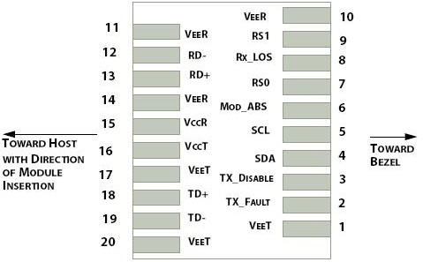
Interface to Host PCB

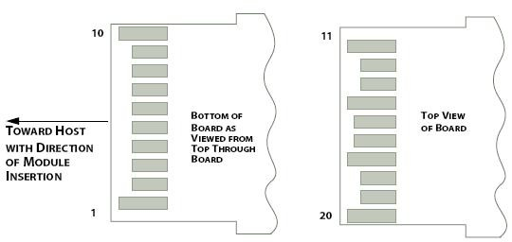
Module Contact Assignment
Pin | Symbol | Name/Description
1 | VEET [1] | Transmitter Ground
2 | Tx_FAULT [2] | Transmitter Fault
3 | Tx_DIS [3] | Transmitter Disable. Laser output disabled on high or open
4 | SDA [2] | 2-wire Serial Interface Data Line
5 | SCL [2] | 2-wire Serial Interface Clock Line
6 | MOD_ABS [4] | Module Absent. Grounded within the module
7 | RS0 [5] | RS0 for Rate Select: Open or Low = Module supports ≤4.25Gbps High = Module supports 9.95 Gb/s to 10.3125 Gb/s
8 | RX_LOS [2] | Loss of Signal indication. Logic 0 indicates normal operation
9 | RS1 [5] | No connection required
10 | VEER [1] | Receiver Ground
11 | VEER [1] | Receiver Ground
12 | RD- | Receiver Inverted DATA out. AC Coupled
13 | RD+ | Receiver DATA out. AC Coupled
14 | VEER [1] | Receiver Ground
15 | VCCR | Receiver Power Supply
16 | VCCT | Transmitter Power Supply
17 | VEET [1] | Transmitter Ground
18 | TD+ | Transmitter DATA in. AC Coupled
19 | TD- | Transmitter Inverted DATA in. AC Coupled
20 | VEET [1] | Transmitter Ground
SFP+ Module PIN Definition

SFP Module EEPROM Information and Management
The SFP modules implement the 2-wire serial communication protocol as defined in the SFP -8472. The serial ID information of the SFP modules and Digital Diagnostic Monitor parameters can be accessed through the I2C interface at address A0h and A2h. The memory is mapped in Table 1. Detailed ID information (A0h) is listed in Table 2. And the DDM specification at address A2h. For more details of the memory map and byte definitions, please refer to the SFF-8472, “Digital Diagnostic Monitoring Interface for Optical Transceivers”. The DDM parameters have been internally calibrated.
Table 1. Digital Diagnostic Memory Map (Specific Data Field Descriptions)
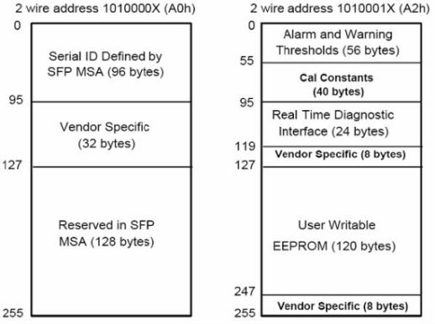

Table 2 - EEPROM Serial ID Memory Contents (A0h)
Data Address | Length (Byte) | Name of Length | Description and Contents
Base ID Fields
0 | 1 | Identifier | Type of Serial transceiver (03h=SFP)
1 | 1 | Reserved | Extended identifier of type serial transceiver (04h)
2 | 1 | Connector | Code of optical connector type (07=LC)
3-10 | 8 | Transceiver | 10G Base-LR
11 | 1 | Encoding | 64B/66B
12 | 1 | BR, Nominal | Nominal baud rate, unit of 100Mbps
13-14 | 2 | Reserved | (0000h)
15 | 1 | Length(9um) | Link length supported for 9/125um fiber, units of 100m
16 | 1 | Length(50um) | Link length supported for 50/125um fiber, units of 10m

17 | 1 | Length(62.5um) | Link length supported for 62.5/125um fiber, units of 10m
18 | 1 | Length(Copper) | Link length supported for copper, units of meters
19 | 1 | Reserved
20-35 | 16 | Vendor Name | SFP vendor name: STONET
36 | 1 | Reserved
37-39 | 3 | Vendor OUI | SFP transceiver vendor OUI ID
40-55 | 16 | Vendor PN | Part Number: (ASCII)
56-59 | 4 | Vendor rev | Revision level for part number
60-62 | 3 | Reserved
63 | 1 | CCID | Least significant byte of sum of data in address 0-62
Extended ID Fields
64-65 | 2 | Option | Indicates which optical SFP signals are implemented (001Ah = LOS, TX_FAULT, TX_DISABLE all  supported)
66 | 1 | BR, max | Upper bit rate margin, units of %
67 | 1 | BR, min | Lower bit rate margin, units of %
68-83 | 16 | Vendor SN | Serial number (ASCII)
84-91 | 8 | Date code | STONET’s Manufacturing date code
92-94 | 3 | Reserved
95 | 1 | CCEX | Check code for the extended ID Fields (addresses 64 to 94)
Vendor Specific ID Fields
96-127 | 32 | Readable | STONET specific date, read only
128-255 | 128 | Reserved | Reserved for SFF-8079
Digital Diagnostic Monitor Characteristics

Data Address | Parameter | Accuracy | Unit
96-97 | Transceiver Internal Temperature | ±3.0 | °C
100-101 | Laser Bias Current | ±10 | %
100-101 | Tx Output Power | ±3.0 | dBm
100-101 | Rx Input Power | ±3.0 | dBm
100-101 | VCC3 Internal Supply Voltage | ±3.0 | %
Regulatory Compliance
The SFP+ complies with international Electromagnetic Compatibility (EMC) and international safety requirements and standards (see details in Table following).
Electrostatic Discharge (ESD) to the Electrical Pins | MIL-STD-883E  Method 3015.7 | Class 1(>1000 V)

Electrostatic Discharge (ESD)  to the Duplex LC Receptacle | IEC 61000-4-2 GR-1089-CORE | Compatible with standards
Electromagnetic Interference (EMI) | FCC Part 15 Class B  EN55022 Class B (CISPR 22B)  VCCI Class B | Compatible with standards
Laser Eye Safety | FDA 21CFR 1040.10 and 1040.11 EN60950, EN (IEC) 60825-1,2 | Compatible with Class 1 laser product.

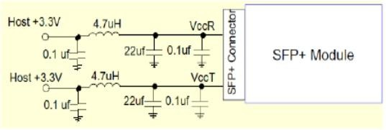
Recommended Circuit
Recommended Host Board Power Supply Circuit
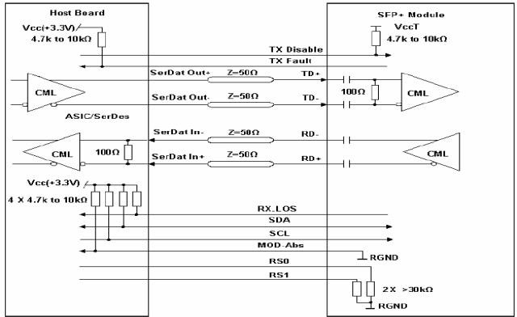
Recommended High-speed Interface Circuit

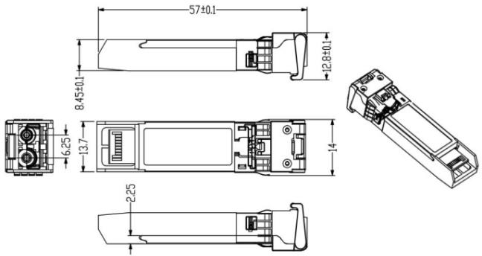

Unit:mm
ESD
This transceiver is specified as ESD threshold 1kV for high speed pins and 2kV for all other electrical input pins, tested per MIL-STD-883, Method 3015.4 /JESD22-A114-A (HBM). However, normal ESD precautions are still required during the handling of this module. This transceiver is shipped in ESD protective packaging. It should be removed from the packaging and handled only in an ESD protected environment.
ESD
This transceiver is specified as ESD threshold 1kV for high speed pins and 2kV for all other electrical input pins, tested per MIL-STD-883, Method 3015.4 /JESD22-A114-A (HBM). However, normal ESD precautions are still required during the handling of this module. This transceiver is shipped in ESD protective packaging. It should be removed from the packaging and handled only in an ESD protected environment.

Part Number | Product Description
SPT-P13TG-LR | 10Gbps SFP+ Optical Transceiver, 10km Reach, 0ºC ~ +70ºC, DDM

