8GE POE+2GE Uplink+2SFP Switch

P112GS
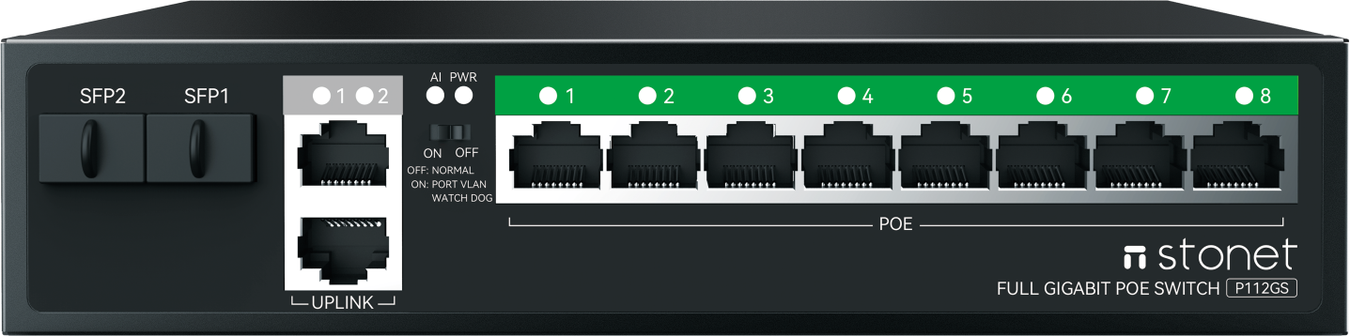
OVERVIEW：
Stonet P112GS provides 8 10/100/1000M adaptive RJ45 ports,2 1000M adaptive RJ45 cascaded ports and 2 SFP Gigabit ports; Ports 1 to 8 support standard POE power supply, and the ports can automatically detect and identify the power device that conforms to the IEEE 802.3AT/AF standard and supply power to it through the network cable, which can be used as an Ethernet power supply device.Not only can rack, desktop multi-way installation, but also has AI+VLAN; AI Monitor: Automatically detect and handle network anomalies in front-end devices (AI watchdog).
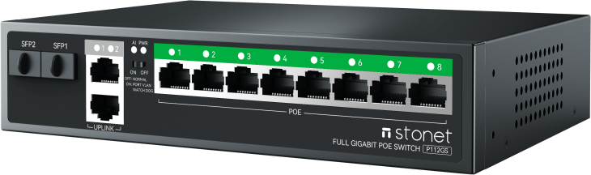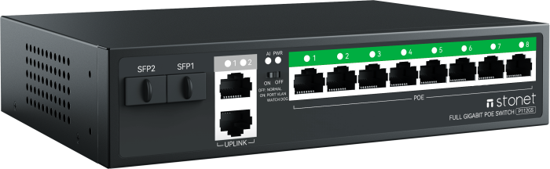
FEATURES：
• 8 10/100/1000M adaptive RJ45 ports,2 1000M adaptive RJ45 cascaded ports,2 SFP Gigabit ports
• Follow IEEE 802.3 Ethernet and IEEE802.3u Fast Ethernet Protocol
• POE IEEE 802.3af/at compliant Powered Device (PD)
• Supporting normal switch/automatic AI detection + port isolation (combined function) second mode
• Auto MDI/MDIX crossover for all ports
• Support full duplex based on IEEE802.3x and half duplex based on Backpressure
• All ports have wire-speed forwarding capability
• MAC address auto-learning & auto-aging
• Power supply: built-in 120W

SPECIFICATION：
Hardware
Interface | 8*1000Mbps POE RJ45 ports + 2*Gigabit cascaded RJ45 ports + 2*Gigabit SFP ports
LED | PWR - Lighting:The product is powered on  Function indication - Lighting:The function switch is on and AI+VLAN port isolation is enabled  Port lights - Lighting:Port link is normal,Blinking: Data in transit
Backplane bandwidth | 24G
MAC Address Table Size | 2K
Cabling type | 1000Base-T: 4 pairs of Cat5e or above UTP/STP(≤100m)  100Base-TX: 2 pairs of class 5 (Cat5) or more UTP/STP(≤100m)  10Base-TX: 2 pairs of class 5 (Cat6) or above UTP/STP(≤250m)
Power supply | AC input 100-240V, standard 120W power supply
Software
Basic function | Follow IEEE 802.3 Ethernet and IEEE802.3u Fast Ethernet Protocol  Supports POE IEEE 802. 3af/at compliant Powered Device (PD)  Store-and-forward switching scheme  Compatible with certified non-standard electrified equipment (PD)  Support IEEE802.3X full duplex and Backpressure half duplex  MAC address auto-learning & auto-aging  VLAN port isolation  AI Monitor
Standards | IEEE 802.3 10BASE-T Ethernet  IEEE 802.3i 10BASE-T Ethernet  IEEE 802.3u 100BASE-TX Fast Ethernet  IEEE 802.3ab 1000BASE-T Gigabit Ethernet  IEEE 802.3af/at, Power over Ethernet  IEEE 802.3x Flow Control
Mode | Normal (default mode)  VLAN (AI+ port isolation)
Data Transfer Rate | 10Mbps(Half-duplex and Full-duplex)  100Mbps(Half-duplex and Full-duplex)  1000Mbps(Full-duplex)
Others
Environment | Operation Temperature：0℃～40℃  Storage Temperature：-40℃～70℃  Operation Humidity：10%～90% RH Non-condensing  Storage Humidity：5%～90% RH Non-condensing
Dimensions | 190*140*43mm(L x W x H )

