


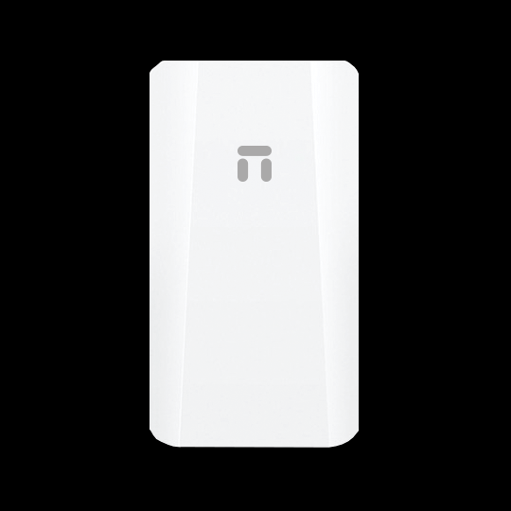
NB10
500 meters high-power monitoring wireless bridge
OVERVIEW:

The NB10 is a high-performance enterprise-grade outdoor wireless bridge product that operates in the 2.4GHz frequency band and supports 802.11n technology. With its unique digital display pairing technology, it doesn't require computer configuration and easily completes the pairing of point-to-point and point-to-multipoint (up to 8 points) devices. It features a 100Mbps network interface and supports up to 300Mbps wireless processing speed with 2.4GHz 802.11n MIMO technology. The power supply can be flexible, supporting 24V PoE Ethernet power supply and 12V 1A DC local power supply. The Ethernet power supply distance can reach up to 50-70 meters (depending on the Ethernet cable material). Designed with an outdoor IP65-rated casing, it provides protection against wind, rain, dust, and sunlight, making it suitable for various harsh outdoor environments. It has a built-in 8dBi directional panel antenna, allowing for easy and quick installation. The product boasts high performance, high gain, high reception sensitivity, and high bandwidth, greatly enhancing wireless transmission performance and stability. It is mainly suitable for places such as elevator monitoring.

HARDWARE FEATURES：
Industrial-grade hardware design, with stable performance
Industrial-grade device with resistance to high and low temperatures, built-in multiple protections against electrostatic discharge, surges, and fast electrical pulses, easily adapts to various harsh environments, ensuring long-term stability and reliable operation.

IP65 protection grade
Designed with outdoor IP65 protection against wind, rain, dust, and sunlight, easily adapts to various outdoor harsh environments.

Powerful wireless transmission capability
Professional RF circuit adjustment to enhance RF transmission power and reception sensitivity, improving wireless transmission distance, performance, and stability.

Flexible Deployment
Flexible power supply options, supporting 24V PoE remote power supply and DC 12V local power supply, with PoE Ethernet remote power supply distance of up to 70 meters.

Perfect hardware configuration
Provides 802.11b/g/n WiFi 300M wireless transmission, paired with 8dBi directional panel antennas, achieving a range of up to 500 meters in open, unobstructed environments. Also provides 10/100Mbps wired Ethernet access, with a throughput of 90+Mbps.

Small fashion, easy to install
Compact in size, supports wall mounting and pole installation, easy to install.

SOFTWARE FEATURES:
Excellent security guarantee
Default bridge SSID hiding and WPA2 data encryption to effectively ensure user data security.

Smart Signal Indicator LED
Three signal LED Lights represent the currently signal strength that SIG1 receives from peer device. It is helpful to find the right location to deploy the device and achieve a better performance.

Simple Overview of the equipment
Simple and clear web management interface for easy bridge configuration.

One-click pairing, plug-and-play
No need for professional knowledge or computer operation, easy pairing of the bridge through simple dialing and button pressing. Supports up to 8 point-to-point connections.

Simple and efficient system configuration
Network time, access password modification, local backup/restore settings, restore factory settings,local/online upgrade, immediate/timed restart, simple and clear features allow you to easily complete the system settings of the device and enhance the robustness of the device.

SPECIFICATION：
Hardware Configuration
Model | NB10
Main chip | MT7628KN
Frequency | 575MHz
Memory | 8MB
Flash | 1MB
Wireless Technology | 802.11b/g/n 300Mbps MIMO
Device Interfaces | LAN*1 10/100Mbps adaptive Ethernet ports  DC power interface, compatible with power plugs with an outer diameter of 5.5mm, inner diameter of 2.1mm, and length of 9.5mm or above
Buttons | Reset Factory/ Digital Compound Button, short press to adjust the numeric display value, long press for 5 seconds to restore factory settings.
Indicators | PWR power indicator, LAN port status indicator,  SIG1/SIG2/SIG3 signal strength indicators,  numeric display.
Antenna | Built-in dual-polarization 8dBi directional panel antenna (horizontal beamwidth 90°, vertical beamwidth 90°)
Power | 24V/0.5A PoE remote power supply  DC 12V/1A, positive external and negative internal
WIRELESS FEATURES
Frequency Range | 802.11b/g/n:2.4~2.4835GHz
Channel | 1、2、3、4、5、6、7、8、9、10、11、12、13
Modulation | 802.11b: DSSS (DQPSK, DBPSK, CCK)  802.11g: OFDM (BPSK, QPSK,16-QAM)  802.11n: OFDM (BPSK, QPSK,16-QAM, 64-QAM)
Transmission Rate | 11b up 11Mbps，11g up 54Mbps，11n up 300Mbps
Receiver  Sensitivity | 11b：≤-90±1.5dBm @1Mbps，  ≤-84±1.5dBm @11Mbps  11g：≤-86±1.5dBm @6Mbps，  ≤-69±1.5dBm @54Mbps  11n 20MHz：≤-85±1.5dBm @MCS0，  ≤-67±1.5dBm @MCS7  11n 40MHz：≤-82±1.5dBm @MCS0，  ≤-64±1.5dBm @MCS7
Transmit Power | 11b: ≥17±1.5dBm@11Mbps  11g: ≥15dBm±1.5dBm@54Mbps  11n: ≥14dBm±1.5dBm@MCS7
SOFTWARE FEATURES
Operation Mode | Bridge Access Point, Bridge Client
Network Topology | Point-to-Point, Point-to-Multipoint (up to eight points)
Management Method | WEB remote management / Local  centralized management platform for bulk  management
Status | The system state/Bridge Status/Interface Status
Bridge | Wireless Mode: Bridge access point/Bridge client  Bridge access point: Bridge SSID/Encryption/Bridge  Password/Wireless protocol/Wireless bandwidth/  Wireless channel/Wireless TX power  Bridge client: Bridge SSID/Encryption/Bridge  Password/MAC /Wireless channel/Wireless TX power
Network | Obtain IP address: Automatic acquisition/Static IP  IP address/Subnet mask/Gateway/DNS1/DNS2
System | System Debug/Change Password/Reboot/Reset  /Upgrade
OTHERS
Package Contents | 1* NB10  1* 24V PoE Power Adapter  2* Plastic Clamps  1* RJ45 Ethernet Cable  1* Quick Installation Guide
System Requirements | Microsoft Edge,Internet Explorer 11+, Firefox 12.0+, Chrome 20.0+, Safari 4.0+, or other JavaScript-enabled browser Cable Subscription with an internet service provider (for internet access)
Operating/Storage Temperature | -30℃～55℃/  -40℃～70℃
Operating/Storage Humidity | 10％～90％(operating)  /5％～95％(storage)
Dimensions | 140*75*34mm
Weight | 0.15kg

